 | Arrival | Instruction | Centers | Instruments | Games | Dismissal
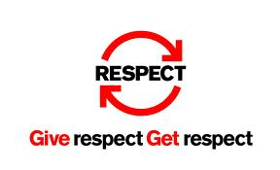  Respect | -Level 1 voice  -Walking feet | -Level 0,1, or 2  voice  -Respect other’s  opinions and  answers  -Wait to be called  on  -Sit up | -Level 2 voice  -Raise your hand if  you need help  -Respect other’s  opinions and  answers | -Level 0 voice  (Level 1 or 2  instruments)  -Be gentle  -Play only when  told | -Level 2 voice  -Respect other’s  abilities  -Follow start/stop  signals | -Level 0 voice  -Walking feet
  Ownership | -Do jobs as assigned  -Share problems/ issues with Music Teacher | -Accept the  outcome  -Fix it | -Read the  directions first  -Ask for help when  needed  -Learn from  mistakes | -Accept the  outcome  -Fix it | -Be honest  -Accept the  outcome  -Fix it | -Do jobs as assigned  -Share problems/  issues with Music Teacher
  Attitude | -Use good manners  -Be ready to work | -Try your best  -Use good  manners | -Try your best  -Use good manners | -Try your best  -Use good  manners | -Try your best  -Be a good sport  -Use kind words  -Use good  manners | -Use good manners  -Check it at the door
  Responsibility | -Go right to your spot  -Grab books (as told)  -Follow Haydn Hippo  Rules  -Spit out gum/candy | -Actively  participate  -Eyes in your book  -Follow fidget  rules | -Use materials  properly  -Stay on task  -Put materials away | -Use instruments  properly  -Keep quiet during  instruction  -Put instruments  Away nicely | -Follow game  rules  -Actively  participate | -Put materials away  -Exit with the class
  Safety | -Walking feet  -Eyes forward  -KHFOOTY | -KHFOOTY | -KHFOOTY | -Walking feet  -Walk around instruments  -Use 2 hands to  carry instruments | -Stay in control of  your body  -Be aware of the  space you have | -Walking feet  -Eyes forward  -KHFOOTY
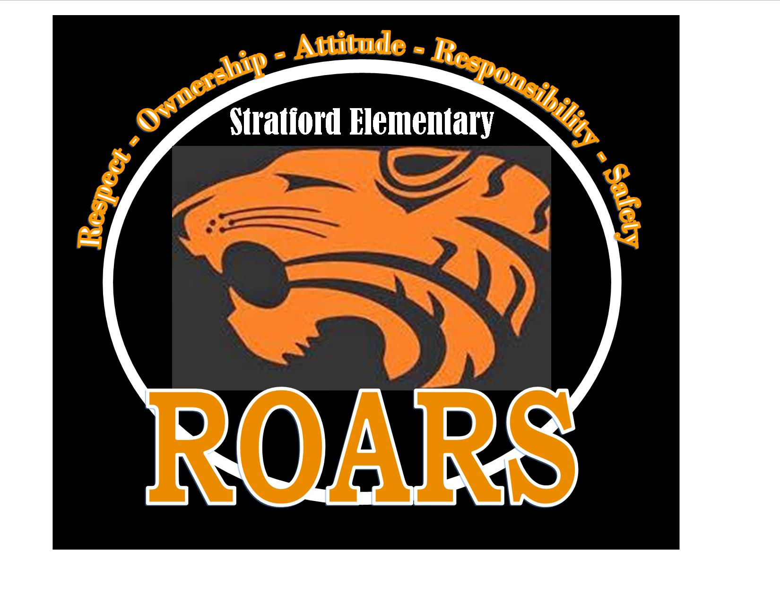
STRATFORD ELEMENTARY MUSIC ROARS!

